|  |  |
| --- | --- |
| **Sector (SIC07)** | **% of Employment In Lancashire** |
| Wholesale and Retail Trade | 17.6% |
| Human health and social work activities | 14.7% |
| Manufacturing | 13.6% |
| Education | 9.1% |
| Administrative and support service activities | 7.2% |
| Accommodation and food service activities | 7.1% |
| Construction | 5.8% |
| Professional, scientific and technical activities | 5.5% |
| Public administration and defence; compulsory social security | 4.9% |
| Transportation and storage | 4.1% |

|  |  |
| --- | --- |
| **Sector (£2016m)** | **2018 GVA (£m)** |
| Manufacturing | £6,329 |
| Wholesale and retail trade; repair of motor vehicles | £5,080 |
| Real estate activities | £3,850 |
| Human health and social work activities | £3,083 |
| Construction | £2,327 |
| Education | £2,114 |
| Public administration and defence | £1,599 |
| Professional, scientific and technical activities | £1,350 |
| Administrative and support service activities | £1,315 |
| Agriculture, mining, electricity, gas, water and waste | £1,165 |

Economic Overview Page 1 of 2

Figure 5: Employment level (% of economically active population). Source: ONS Annual Population Survey, April 2019-March 2020

Figure 3: Population age distribution. Source: Population estimates - local authority, based by five year age band, 2019

Figure 1: Sector GVA. Source: ONS Regional gross value added (balanced) by industry: local authorities by NUTS 1 region: UKD North West, 2019

Figure 2: Sector Employment as a percentage of all employment. Source: Business Register and Employment Survey, 2018

Figure 4: Highest qualification level. Source: Annual Population Survey, 2019

|  |  |  |  |
| --- | --- | --- | --- |
| **Area** | **Aged 0 - 15** | **Aged 16 - 64** | **Aged 65 +** |
| Lancashire | 19.0% | 60.9% | 20.1% |
| North West | 19.1% | 62.1% | 18.7% |
| United Kingdom | 19.0% | 62.5% | 18.5% |

Economic Overview Page 2 of 2

Figure 7: Gross Median Household Disposable Income by Local Authority. Source: ONS Regional GDHI at current prices, 2016

Figure 6: Percentage of employees in Lancashire by Standard Occupational Classification. Source: Business Register and Employment Survey, 2018

UK average: £19.4k

|  |  |  |  |
| --- | --- | --- | --- |
|  | **July 2020 Claimant Count (%)** | | |
| **Age Band** | **Lancashire** | **North West** | **Great Britain** |
| Aged 16+ | 6.9 | 7.2 | 6.5 |
| Aged 18 To 24 | 10.1 | 10.4 | 9.3 |
| Aged 18 To 21 | 9.9 | 10.2 | 9.1 |
| Aged 25 To 49 | 7.8 | 8.1 | 7 |
| Aged 50+ | 5 | 5 | 4.9 |

|  |  |  |  |
| --- | --- | --- | --- |
| **Sector (SIC07)** | **Furloughed NW** | **Furlough Rate NW** | **Furlough Rate UK** |
| Wholesale and retail | 204,800 | 40% | 40% |
| Accommodation & food | 172,500 | 75% | 73% |
| Manufacturing | 109,700 | 36% | 40% |
| Business administration and support services | 87,200 | 28% | 30% |
| Construction | 77,500 | 57% | 59% |

COVID Impact

COVID-19 Impact

Figure 9: North West sector furlough numbers July 2020. Source: HMRC’s Coronavirus Job Retention Scheme claims data, July 2020

Figure 8: Claimant count by Local Authority. Source: ONS Claimant count by sex and age

Figure 8: Claimant count by age band, Source: ONS Claimant count by sex and age

|  |  |  |  |
| --- | --- | --- | --- |
| **Month** | **Male** | **Female** | **Lancashire Total** |
| March 2020 | 4.4 | 3.0 | 3.7 |
| April 2020 | 7.3 | 4.7 | 6.0 |
| May 2020 | 8.7 | 5.2 | 7.0 |
| June 2020 | 8.4 | 5.2 | 6.8 |
| July 2020 | 8.6 | 5.3 | 6.9 |
| **March to July Change** | **4.2** | **2.3** | **3.2** |

Figure 11: Furlough Percentages (% of eligible employments) by Local authority vs UK and Lancashire LEP. Source: HMRC’s Coronavirus Job Retention Scheme claims data, July 2020

Figure 10: Claimant Count % by gender, Lancashire. Source: ONS Claimant count by sex and age

Future Workforce

Future Workforce

Figure 13: Percentage of Employers reporting skills shortage vacancies by Standard occupational classification. Source: UK Employer Skills Survey, Incidence of skills shortage vacancies by occupation - (employer base), 2017.

Figure 12: Average attainment 8 score by Local Authority. Source: Key stage 4 performance 2019, 2020.

Figure 13: % of 16 and 17 year olds who are NEET. Source: NEET and Participation Tables, 2020.

Figure 14: Gross median take home weekly pay by Local Authority vs UK level. Source: ONS Regional GDHI at current prices, 2016

|  |  |  |
| --- | --- | --- |
| **Area** | **Gross Weekly Pay (median £)** | **Vs UK (£)** |
| Blackburn with Darwen | 491.2 | -93.7 |
| Blackpool | 454.6 | -130.3 |
| Bury | 582.6 | -2.3 |
| Chorley | 609.0 | 24.1 |
| Fylde | 614.7 | 29.8 |
| Hyndburn | 484.9 | -100.0 |
| Lancaster | 546.0 | -38.9 |
| Pendle | 536.4 | -48.5 |
| Preston | 502.9 | -82.0 |
| Ribble Valley | 622.6 | 37.7 |
| Rossendale | 512.8 | -72.1 |
| South Ribble | 565.5 | -19.4 |
| West Lancashire | 581.1 | -3.8 |
| Wyre | 499.5 | -85.4 |

Inclusive Workforce

Inclusive Workforce

Figure 16: Unemployment rate as a % of economically active population by gender. Source: ONS Annual Population Survey, April 2019 – March 2020

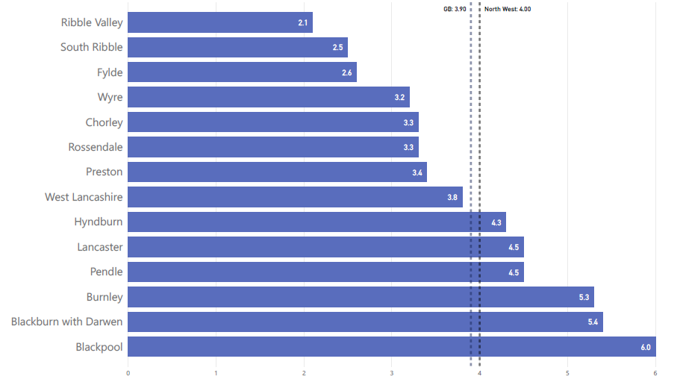

Figure 15: Economically active % of resident population by gender. Source: ONS Annual Population Survey, April 2019 – March 2020

Figure 17: Overall Index of Multiple Deprivation (index of all measures) rank by local authority including nationwide decile. Source: MHCLG 2019 English Indices of Deprivation

Figure 16: Unemployment rate as a % of economically active population by Local Authority. Source: ONS Annual Population Survey, April 2019 – March 2020

|  |  |  |
| --- | --- | --- |
| **Local Authority** | **IMD Average Rank** | **IMD decile** |
| Blackpool | 1 | 1 |
| Burnley | 11 | 1 |
| Blackburn with Darwen | 14 | 1 |
| Hyndburn | 18 | 1 |
| Pendle | 36 | 2 |
| Preston | 46 | 2 |
| Rossendale | 91 | 3 |
| Lancaster | 112 | 4 |
| Wyre | 147 | 5 |
| West Lancashire | 178 | 6 |
| Chorley | 192 | 7 |
| Fylde | 198 | 7 |
| South Ribble | 210 | 7 |
| Ribble Valley | 282 | 9 |

Skilled and Productive Workforce

Skilled and Productive Workforce

|  |  |  |  |  |  |  |
| --- | --- | --- | --- | --- | --- | --- |
|  | **Apprenticeship Starts** | | | **Percentage Changes in Apprenticeship Starts** | | |
| **Area** | **2016/17** | **2017/18** | **2018/19** | **% Change 16/17 to 17/18** | **% Change 17/18 to 18/19** | **% Change Q3 18/19 to Q3 19/20** |
| **Lancashire** | 17,850 | 12,020 | 13,070 | -32.7% | 8.7% | -10% |
| **National** | 530,100 | 401,620 | 422,130 | -24.2% | 5.1% | -12.6% |

Figure 18: 2019/20 Apprenticeship Starts 2016/17 to 2019/20 Q3. Source: DfE Datacube

|  |  |
| --- | --- |
| **NUTS Region** | **2018 GVA (£)** |
| **United Kingdom** | **28,729** |
| **North West** | **25,118** |
| **Lancashire** | **22,765** |
| Mid Lancashire | 30,279 |
| East Lancashire | 21,773 |
| Blackburn with Darwen | 21,208 |
| Blackpool | 20,347 |
| Chorley and West Lancashire | 20,032 |
| Lancaster and Wyre | 17,214  Figure 19: GVA per Head of the population, NUTS regions. Source: ONS Regional GVA Balanced Approach |

|  |  |
| --- | --- |
| **Local Authority** | **GVA 2018 (£2016m)** |
| Blackburn with Darwen | 3,050 |
| Blackpool | 2,722 |
| Lancaster | 2,643 |
| Wyre | 1,579 |
| Fylde | 2,036 |
| Preston | 4,312 |
| Ribble Valley | 1,531 |
| South Ribble | 3,610 |
| Burnley | 2,246 |
| Hyndburn | 1,459 |
| Pendle | 2,187 |
| Rossendale | 1,076 |
| Chorley | 2,014 |
| West Lancashire | 2,481 |

|  |  |  |
| --- | --- | --- |
| Skill Level | Lancashire Demand Change | UK Demand Change |
| NVQ 4+ | 4% | 6% |
| NVQ 3 | 5% | 8% |
| NVQ 2 | -5% | -3% |
| NVQ 1 | -4% | -2% |
| Other | 16% | 18% |
| No quals | -7% | -5% |



|  |  |  |
| --- | --- | --- |
| Area | Male | Female |
| England | 63yrs | 64yrs |
| North West region | 61yrs | 62yrs |
| Lancashire | 61yrs | 65yrs |



Figure 21: Forecast Demand for Skill Levels, 2028, Lancashire. Source: Oxford Economics analysis for the Lancashire Labour Market Intelligence Toolkit, 2018

Figure 24: Replacement Demand by Sector, Lancashire, 2018-2028. Source: Oxford Economics, Local Authority Databank

Figure 22: Percentage of hours lost annually due to sickness, by local authority. Only local authorities with statistically reliable data have been included. Source: ONS Sickness Absence Rate by Local Authority, 2017

Figure 23: Healthy Life Expectancy by Gender, 2017. Source: Public Health England, 2015-17

Figure 20: GVA By Local Authority (Balanced). Source: ONS Regional gross value added (balanced) by industry: local authorities by NUTS 1 region: UKD North West, 2019